验8 数据存储和共享

## 一、实验目的

* 熟练掌握Android网络数据库连接。
* 掌握android 操作webService的方法。

## 二、实验要求

* 实现上述的基本功能要求。自定义界面和功能。
* 实验报告提交内容：1）结合系统界面（截图）介绍APP功能；2）核心实现代码（Java或Kotlin代码）和布局文件等。

## 三、实验内容

Step1：Working with the MainActivity.java

**package** com.example.mydbms2;  
  
**import** androidx.appcompat.app.AppCompatActivity;  
  
**import** android.os.Bundle;  
  
  
**import** android.app.Activity;  
**import** android.content.Intent;  
**import** android.os.Bundle;  
**import** android.provider.ContactsContract;  
**import** android.view.ContextMenu;  
**import** android.view.MenuItem;  
**import** android.view.View;  
**import** android.widget.AdapterView;  
**import** android.widget.Button;  
**import** android.widget.EditText;  
**import** android.widget.ListView;  
**import** android.widget.SimpleAdapter;  
**import** android.widget.Toast;  
  
**import** java.util.ArrayList;  
**import** java.util.HashMap;  
**import** java.util.List;  
**import** java.util.Map;  
  
**public class** MainActivity **extends** AppCompatActivity {  
  
  
 **private** DBAdapter **db**;  
 **private** Button **bt_add**;  
 **private** EditText **et_name**;  
 **private** EditText **et_number**;  
 **private** EditText **et_class**;  
 **private** ListView **listview**;  
 **private** Student **student**;  
 **private int position**;  
 **private** SimpleAdapter **simpleAdapter**;  
 Map<String, Object> **item** = **new** HashMap<String, Object>();  
 **private** List<Map<String, Object>> **Datas** = **new** ArrayList<Map<String, Object>>();  
  
  
  
 @Override  
 **protected void** onCreate(Bundle savedInstanceState) {  
 **super**.onCreate(savedInstanceState);  
 setContentView(R.layout.***activity_main***);  
  
  
 **bt_add** = (Button) findViewById(R.id.***bt_add***);  
 **et_name** = (EditText) findViewById(R.id.***et_name***);  
 **et_number** = (EditText) findViewById(R.id.***et_number***);  
 **et_class** = (EditText) findViewById(R.id.***et_class***);  
 **listview** = findViewById(R.id.***listview***);  
 **this**.registerForContextMenu(**listview**);  
  
 **db** = **new** DBAdapter(MainActivity.**this**);  
 **db**.open();  
  
 **bt_add**.setOnClickListener(**new** View.OnClickListener() {  
 @Override  
 **public void** onClick(View view) {  
  
 String cl = **et_class**.getText().toString();  
 String num = **et_number**.getText().toString();  
 String na = **et_name**.getText().toString();  
 **student** = **new** Student(cl, num, na);  
 **long** colunm = **db**.insert(**student**);  
  
 **Datas**.clear();  
 display();  
 Toast.*makeText*(MainActivity.**this**, **"Added Successful"**, Toast.***LENGTH_SHORT***).show();  
 }  
 });  
  
 display();  
 }  
  
 @Override  
 **public void** onCreateContextMenu(ContextMenu menu, View v, ContextMenu.ContextMenuInfo  
 menuInfo) {  
 **super**.onCreateContextMenu(menu, v, menuInfo);  
  
 menu.add(0, 1, 0, **"Delete"**);  
  
 AdapterView.AdapterContextMenuInfo info = (AdapterView.AdapterContextMenuInfo) menuInfo;  
 **position** = info.**position**;  
 }  
  
 @Override  
 **public boolean** onContextItemSelected(MenuItem item) {  
  
 AdapterView.AdapterContextMenuInfo menuInfo = (AdapterView.AdapterContextMenuInfo) item.getMenuInfo();  
 **int** pos = (**int**) **listview**.getAdapter().getItemId(menuInfo.**position**);  
  
 Map<String, Object> stu = **Datas**.get(pos);  
 **switch** (item.getItemId()) {  
 **case** 1:  
 **db**.deleteOneData((Integer) stu.get(**"id"**));  
 **Datas**.remove(pos);  
 **simpleAdapter**.notifyDataSetChanged();  
 Toast.*makeText*(MainActivity.**this**, **"ID:"** + stu.get(**"id"**) + **"Delete Successful"**, Toast.***LENGTH_SHORT***).show();  
 **break**;  
 **default**:  
 **break**;  
 }  
 **return super**.onContextItemSelected(item);  
 }  
  
 **public void** display() {  
  
 String[] from = {**"id"**, **"class"**, **"number"**, **"name"**};  
  
 **int**[] to = {R.id.***tv_id***, R.id.***tv_class***, R.id.***tv_number***, R.id.***tv_name***};  
  
 **simpleAdapter** = **new** SimpleAdapter(**this**, **Datas**, R.layout.***item_view***, from, to);  
 **listview**.setAdapter(**simpleAdapter**);  
 Student[] students = **db**.queryAllData();  
 **if** (students == **null**) {  
 **return**;  
 }  
  
 String cl;  
 String num;  
 String na;  
 **int** id;  
 **for** (**int** i = 0; i < students.**length**; i++) {  
 cl = students[i].getClas();  
 num = students[i].getNumber();  
 na = students[i].getName();  
 id = students[i].getID();  
 *//Toast.makeText(MainActivity.this,cl+num+na,Toast.LENGTH_SHORT).show();*  
Map<String, Object> item = **new** HashMap<String, Object>();  
 item.put(**"id"**, id);  
 item.put(**"class"**, cl);  
 item.put(**"number"**, num);  
 item.put(**"name"**, na);  
 **Datas**.add(item);  
 **simpleAdapter**.notifyDataSetChanged();  
 }  
  
  
  
 }  
}

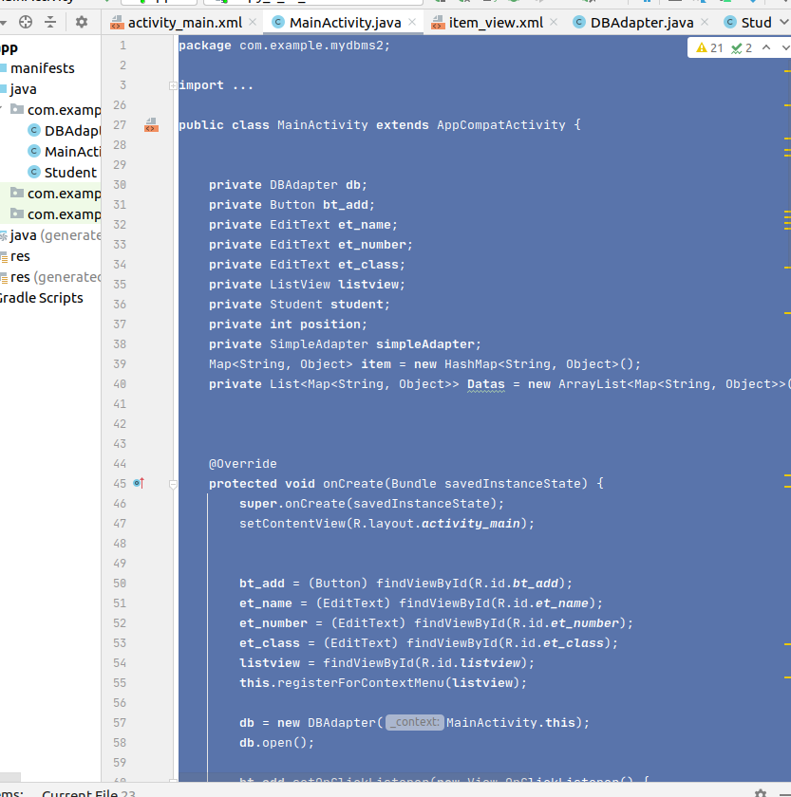

.

step2: Working with the Activity_main.xml

*<?***xml version="1.0" encoding="utf-8"***?>*  
<**LinearLayout xmlns:android="http://schemas.android.com/apk/res/android"**  
 **xmlns:tools="http://schemas.android.com/tools"**  
 **android:layout_width="match_parent"**  
 **android:layout_height="match_parent"**  
 **android:orientation="vertical"**  
 **tools:context=".MainActivity"**>  
  
  
 <**LinearLayout**  
 **android:layout_width="match_parent"**  
 **android:layout_height="wrap_content"**  
 **android:orientation="horizontal"**  
 **android:layout_margin="5dp"**>  
  
 <**TextView**  
 **android:layout_width="0dp"**  
 **android:layout_height="wrap_content"**  
 **android:layout_marginLeft="5dp"**  
 **android:layout_weight="1"**  
 **android:gravity="center"**  
 **android:text="Class:"**  
 **android:textSize="18dp"** />  
  
 <**EditText**  
 **android:id="@+id/et_class"**  
 **android:layout_width="0dp"**  
 **android:layout_height="wrap_content"**  
 **android:layout_marginRight="10dp"**  
 **android:layout_weight="4"**  
 **android:textSize="18dp"** />  
 </**LinearLayout**>  
  
 <**LinearLayout**  
 **android:layout_width="match_parent"**  
 **android:layout_height="wrap_content"**  
 **android:orientation="horizontal"**  
 **android:layout_margin="5dp"**>  
  
 <**TextView**  
 **android:layout_width="0dp"**  
 **android:layout_height="wrap_content"**  
 **android:layout_marginLeft="5dp"**  
 **android:layout_weight="1"**  
 **android:gravity="center"**  
 **android:text="Stdno:"**  
 **android:textSize="18dp"** />  
  
 <**EditText**  
 **android:id="@+id/et_number"**  
 **android:layout_width="0dp"**  
 **android:layout_height="wrap_content"**  
 **android:layout_marginRight="10dp"**  
 **android:layout_weight="4"**  
 **android:textSize="18dp"** />  
 </**LinearLayout**>  
  
 <**LinearLayout**  
 **android:layout_width="match_parent"**  
 **android:layout_height="wrap_content"**  
 **android:orientation="horizontal"**  
 **android:layout_margin="5dp"**>  
  
  
 <**TextView**  
 **android:layout_width="0dp"**  
 **android:layout_height="wrap_content"**  
 **android:layout_marginLeft="5dp"**  
 **android:layout_weight="1"**  
 **android:gravity="center"**  
 **android:text="Name:"**  
 **android:textSize="18dp"** />  
  
 <**EditText**  
 **android:id="@+id/et_name"**  
 **android:layout_width="0dp"**  
 **android:layout_height="wrap_content"**  
 **android:layout_marginRight="10dp"**  
 **android:layout_weight="4"**  
 **android:textSize="18dp"** />  
 </**LinearLayout**>  
  
 <**LinearLayout**  
 **android:layout_width="match_parent"**  
 **android:layout_height="wrap_content"**  
 **android:weightSum="1"**>  
  
  
 <**Button**  
 **android:id="@+id/bt_add"**  
 **android:layout_width="0dp"**  
 **android:layout_height="wrap_content"**  
 **android:layout_marginLeft="10dp"**  
 **android:layout_marginRight="10dp"**  
 **android:layout_marginTop="5dp"**  
 **android:layout_marginBottom="10dp"**  
 **android:layout_weight="1"**  
 **android:text="Add Student Info"**  
 **android:textSize="18dp"** />  
 </**LinearLayout**>  
  
 <**LinearLayout**  
 **android:layout_width="match_parent"**  
 **android:layout_height="wrap_content"**  
 **android:orientation="horizontal"**>  
  
 <**TextView**  
 **android:layout_width="0dp"**  
 **android:layout_height="wrap_content"**  
 **android:layout_weight="0.5"**  
 **android:gravity="center"**  
 **android:text="ID"**  
 **android:textSize="20sp"** />  
  
 <**TextView**  
 **android:layout_width="0dp"**  
 **android:layout_height="wrap_content"**  
 **android:layout_weight="1"**  
 **android:text="Class"**  
 **android:gravity="center"**  
 **android:textSize="20sp"** />  
  
 <**TextView**  
 **android:layout_width="0dp"**  
 **android:layout_height="wrap_content"**  
 **android:layout_weight="1.2"**  
 **android:gravity="center"**  
 **android:text="Stdno:"**  
 **android:textSize="20sp"** />  
  
 <**TextView**  
 **android:layout_width="0dp"**  
 **android:layout_height="wrap_content"**  
 **android:layout_weight="1"**  
 **android:gravity="center"**  
 **android:text="Name"**  
 **android:textSize="20sp"** />  
 </**LinearLayout**>  
  
 <**LinearLayout**  
 **android:layout_width="match_parent"**  
 **android:layout_height="wrap_content"**  
 **android:orientation="horizontal"**>  
  
 <**ListView**  
 **android:id="@+id/listview"**  
 **android:layout_width="match_parent"**  
 **android:layout_height="match_parent"**>  
  
 </**ListView**>  
  
 </**LinearLayout**>  
  
</**LinearLayout**>

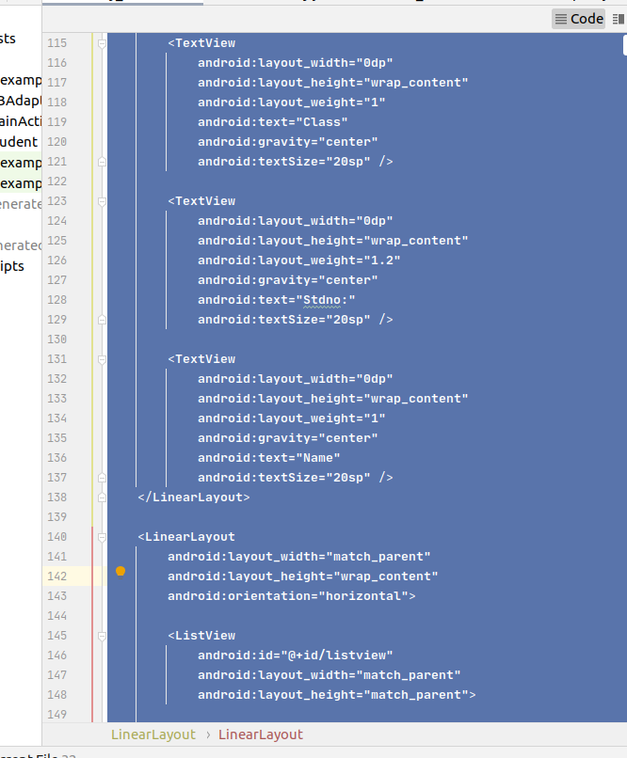.

step3: Working with the DBAdapter.java

**package** com.example.mydbms2;  
  
**import** android.content.ContentValues;  
**import** android.content.Context;  
**import** android.database.Cursor;  
**import** android.database.sqlite.SQLiteDatabase;  
**import** android.database.sqlite.SQLiteDatabase.CursorFactory;  
**import** android.database.sqlite.SQLiteException;  
**import** android.database.sqlite.SQLiteOpenHelper;  
  
  
**public class** DBAdapter {  
  
  
  
 **private static final** String ***DB_NAME*** = **"student.db"**;  
 **private static final** String ***DB_TABLE*** = **"students"**;  
 **private static final int *DB_VERSION*** = 1;  
  
 **public static final** String ***KEY_ID*** = **"_id"**;  
 **public static final** String ***KEY_NAME*** = **"name"**;  
 **public static final** String ***KEY_CLASS*** = **"class"**;  
 **public static final** String ***KEY_NUMBER*** = **"number"**;  
  
 **private** SQLiteDatabase **db**;  
 **private final** Context **context**;  
 **private** DBOpenHelper **dbOpenHelper**;  
  
 **public** DBAdapter(Context _context) {  
 **context** = _context;  
 }  
  
 */\*\**  
 *\* Close the database*  
 *\*/*  
**public void** close() {  
 **if** (**db** != **null**) {  
 **db**.close();  
 **db** = **null**;  
 }  
 }  
  
 */\*\**  
 *\* Open the database*  
 *\*/*  
**public void** open() **throws** SQLiteException {  
 **dbOpenHelper** = **new** DBOpenHelper(**context**, ***DB_NAME***, **null**, ***DB_VERSION***);  
 **try** {  
 **db** = **dbOpenHelper**.getWritableDatabase();  
 } **catch** (SQLiteException ex) {  
 **db** = **dbOpenHelper**.getReadableDatabase();  
 }  
 }  
  
 **public long** insert(Student student) {  
 ContentValues newValues = **new** ContentValues();  
  
 newValues.put(***KEY_NAME***, student.**Name**);  
 newValues.put(***KEY_CLASS***, student.**Clas**);  
 newValues.put(***KEY_NUMBER***, student.**Number**);  
  
 **return db**.insert(***DB_TABLE***, **null**, newValues);  
 }  
  
  
 **public** Student[] queryAllData() {  
 Cursor results = **db**.query(***DB_TABLE***, **new** String[]{***KEY_ID***, ***KEY_NAME***, ***KEY_CLASS***, ***KEY_NUMBER***},  
 **null**, **null**, **null**, **null**, **null**);  
 **return** ConvertToStudent(results);  
 }  
  
 **public** Student[] queryOneData(**long** id) {  
 Cursor results = **db**.query(***DB_TABLE***, **new** String[]{***KEY_ID***, ***KEY_NAME***, ***KEY_CLASS***, ***KEY_NUMBER***},  
 ***KEY_ID*** + **"="** + id, **null**, **null**, **null**, **null**);  
 **return** ConvertToStudent(results);  
 }  
  
 **private** Student[] ConvertToStudent(Cursor cursor) {  
 **int** resultCounts = cursor.getCount();  
 **if** (resultCounts == 0 || !cursor.moveToFirst()) {  
 **return null**;  
 }  
 Student[] students = **new** Student[resultCounts];  
 **for** (**int** i = 0; i < resultCounts; i++) {  
 students[i] = **new** Student();  
 students[i].**ID** = cursor.getInt(0);  
 students[i].**Name** = cursor.getString(cursor.getColumnIndex(***KEY_NAME***));  
 students[i].**Clas** = cursor.getString(cursor.getColumnIndex(***KEY_CLASS***));  
 students[i].**Number** = cursor.getString(cursor.getColumnIndex(***KEY_NUMBER***));  
 cursor.moveToNext();  
 }  
 **return** students;  
 }  
  
 **public long** deleteAllData() {  
 **return db**.delete(***DB_TABLE***, **null**, **null**);  
 }  
  
 **public long** deleteOneData(**int** id) {  
 **return db**.delete(***DB_TABLE***, ***KEY_ID*** + **"="** + id, **null**);  
 }  
  
 **public long** updateOneData(**long** id, Student student) {  
 ContentValues updateValues = **new** ContentValues();  
 updateValues.put(***KEY_NAME***, student.**Name**);  
 updateValues.put(***KEY_CLASS***, student.**Clas**);  
 updateValues.put(***KEY_NUMBER***, student.**Number**);  
  
 **return db**.update(***DB_TABLE***, updateValues, ***KEY_ID*** + **"="** + id, **null**);  
 }  
  
 **private static class** DBOpenHelper **extends** SQLiteOpenHelper {  
  
 **public** DBOpenHelper(Context context, String name, CursorFactory factory, **int** version) {  
 **super**(context, name, factory, version);  
 }  
  
 **private static final** String ***DB_CREATE*** = **"create table "** +  
 ***DB_TABLE*** + **" ("** + ***KEY_ID*** + **" integer primary key autoincrement, "** +  
 ***KEY_NAME*** + **" text not null, "** + ***KEY_CLASS*** + **" text not null,"** + ***KEY_NUMBER*** + **" text not null);"**;  
  
 @Override  
 **public void** onCreate(SQLiteDatabase _db) {  
 _db.execSQL(***DB_CREATE***);  
 }  
  
 @Override  
 **public void** onUpgrade(SQLiteDatabase _db, **int** _oldVersion, **int** _newVersion) {  
 _db.execSQL(**"DROP TABLE IF EXISTS "** + ***DB_TABLE***);  
 onCreate(_db);  
 }  
 }  
}

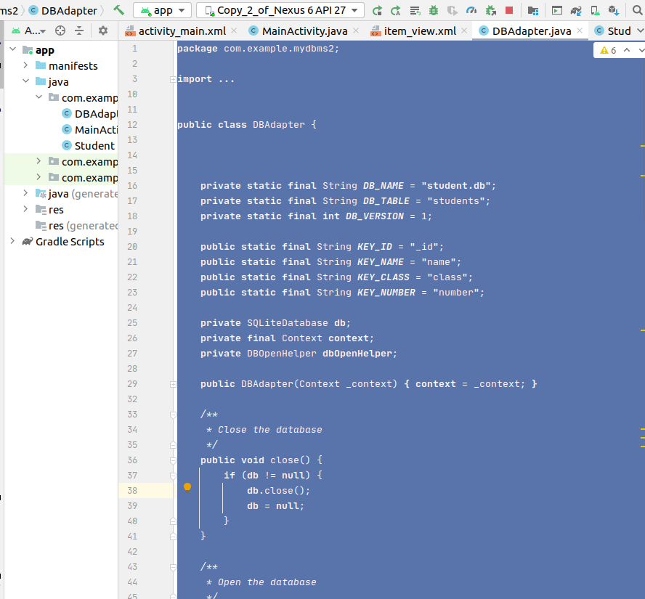.

step4: Working with the Student.java

**package** com.example.mydbms2;  
  
**public class** Student {  
  
 **public int ID** = -1;  
 **public** String **Name**;  
 **public** String **Number**;  
 **public** String **Clas**;  
  
 **public** Student(String Class, String Number, String Name) {  
 **this**.**Clas** = Class;  
 **this**.**Number** = Number;  
 **this**.**Name** = Name;  
 }  
  
 **public** Student() {  
 **super**();  
 }  
  
 **public** String getClas() {  
 **return Clas**;  
 }  
  
 **public** String getName() {  
 **return Name**;  
 }  
  
 **public** String getNumber() {  
 **return Number**;  
 }  
  
 **public int** getID() {  
 **return ID**;  
 }  
  
 @Override  
 **public** String toString() {  
 String result = **""**;  
 result += **this**.**ID** + **" "**;  
 result += **this**.**Clas** + **" "**;  
 result += **this**.**Number** + **" "**;  
 result += **this**.**Name** + **" "**;  
 **return** result;  
 }  
  
}

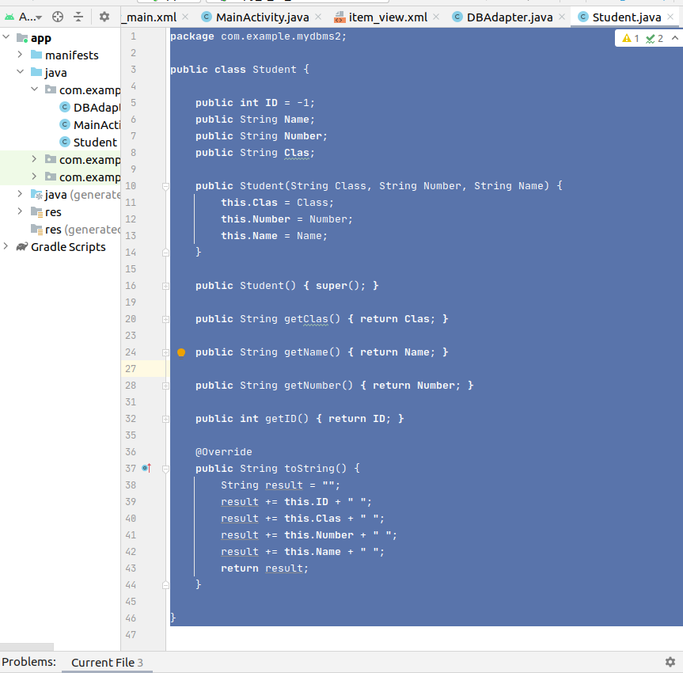

step5: Working with the item_view.xml

*<?***xml version="1.0" encoding="utf-8"***?>*  
<**LinearLayout xmlns:android="http://schemas.android.com/apk/res/android"**  
 **android:layout_width="match_parent"**  
 **android:layout_height="match_parent"**  
 **android:orientation="horizontal"**>  
  
 <**TextView**  
 **android:layout_width="wrap_content"**  
 **android:layout_height="wrap_content"**  
 **android:layout_weight="0.5"**  
 **android:gravity="center"**  
 **android:textSize="16sp"**  
 **android:id="@+id/tv_id"**/>  
  
 <**TextView**  
 **android:layout_width="wrap_content"**  
 **android:layout_height="wrap_content"**  
 **android:layout_weight="1"**  
 **android:textSize="16sp"**  
 **android:gravity="center"**  
 **android:id="@+id/tv_class"**/>  
 <**TextView**  
 **android:layout_width="wrap_content"**  
 **android:layout_height="wrap_content"**  
 **android:layout_weight="1.2"**  
 **android:textSize="16sp"**  
 **android:gravity="center"**  
 **android:id="@+id/tv_number"**/>  
 <**TextView**  
 **android:layout_width="wrap_content"**  
 **android:layout_height="wrap_content"**  
 **android:layout_weight="1"**  
 **android:textSize="16sp"**  
 **android:gravity="center"**  
 **android:id="@+id/tv_name"**/>  
  
  
</**LinearLayout**>

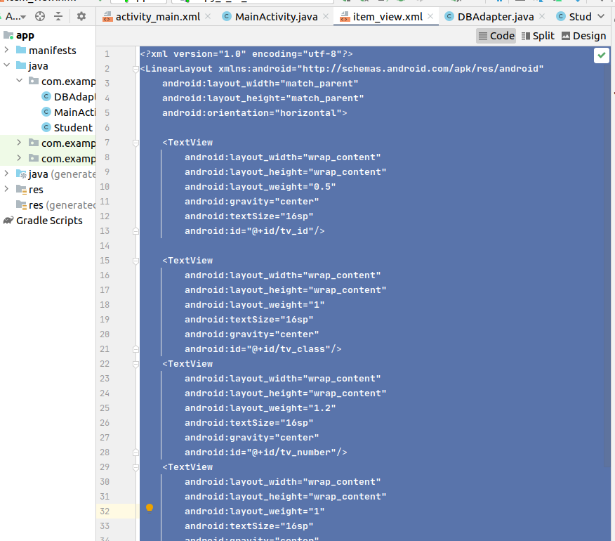.

## 四、实验结果：

